
Bulletin from the LWML Texas District - September 2025

For we are God’s handiwork, created in Christ Jesus to do good works, which God prepared in advance for us to do (Ephesians 2:10 NIV).

THANK YOU for the outpouring of love in the form of quilts and kits at the Texas ingatherings in November 2024. Over 15,300 quilts, 9,360 school kits, 10,468 personal care kits, 1,593 baby care kits and 470 personal care kits were gathered at the three ingatherings in Texas and sent to the LWR warehouses. To God be the Glory!
The 2024 Texas LWR ingathering schedule is on page 2.

KUDOS for Thinking Like a Bug and for the most part doing a super job at packing and labeling the boxes but there is always room for improvement. It might be annoying to label each side, tape up each seam and make sure your label is attached correctly (on the side – not the top) but for the volunteers loading the trucks and for the LWR warehouse workers it is a huge relief. Each year the volunteers have had to re-tape, re-label and sometimes even re-pack to meet standards, so please pack your manageable-size boxes correctly. We appreciate it so much when boxes come in ready to load onto the trucks.

MONETARY DONATIONS WILL NOT BE ACCEPTED AT THE INGATHERING SITES. Any and all monetary donations need to be mailed directly to the Lutheran World Relief headquarters (see page 4).

Friendly reminder that LWR IS NO LONGER ACCEPTING FLEECE BLANKETS LWR has received information that fleece causes environmental concerns and therefore will NOT be collecting them.

And don’t forget LWR IS NOT ACCEPTING BULK SOAP. The Baby Care and Personal Care Kits still require soap. We are just not accepting any soap in separate boxes.

PACKING QUILTS AND KITS:
- Use SMALLER AND STURDY BOXES, no more than 30 lbs. per box or smaller is better.
- Pack only ONE TYPE OF ITEM OR KIT PER BOX and KEEP A TALLY OF ITEMS IN EACH BOX.
- PACK BOXES TIGHTLY. Try sitting on the box to be sure it is tight. If it is “squishy” you may be asked to repack at the collection site.
- TAPE ALL OPEN EDGES AND HOLES IN BOXES WITH MAILING TAPE, no masking tape. See “THINK LIKE A BUG” for more information (see page 3).
- PLACE SHIPPING LABEL ON SIDE OF BOX AND TAPE OVER IT (see page 6).
- LABEL ALL SIDES, TOP AND BOTTOM IN LARGE BLOCK LETTERS WITH LWR AND NUMBER AND TYPE OF ITEM. Example: LWR 5 BABY CARE.
- If you COMBINE YOUR DONATIONS WITH OTHER CHURCHES, the site coordinator will need a copy of the LWR INGATHERING REPORT from each church (see page 5).
- NOTE the Quilt & Kit Trackers is no longer in service.

LWR WEBSITE INFORMATION:
The LWR website, www.lwr.org, has information on the “Get Involved” tab for preparing and packing quilts and kits along with a listing of the items needed for each kit. The ingathering sites can be found on the LWR website: “Get Involved Tab” – “Quilts and Kits” – “Find an Ingathering”. Videos are available on the website also. To order a copy of the LWR Quilt and Kit Ministry guide, call 1-800-597-5972.

Specific items that SHOULD NOT be included or used for quilts and kits are as follows:
- Any item with a religious symbol or message, or your group’s name. Let the Holy Spirit do the heavy lifting on this – we don’t want to cause any repercussions for the recipients of the quilts or kits.
- Any item with a US flag, US patriotic or military symbols, references to the US armed forces or camouflage.
- No plastic bags enclosing the quilts, kits, or any items in them.
- Do not add to or take out any item listed.

NOVEMBER 2025 LWR INGATHERING SITES

 | Houston | Seguin | Dallas
Area Served | Southeast portion of state, including SE-ELCA and other Synods | Del Rio, Kerrville, Austin, Victoria and points south including SW-ELCA and other Synods | Temple to Lufkin and points north and west, including N&NW-ELCA and other Synods
Drop-off Dates | Saturday  Nov 1, 2025 | Wednesday  Nov 5, 2025 | Saturday  Nov 8, 2025
Times | 9:00am – 3:00pm | 9:00am – 2:00pm | 9:00am – 2:00pm
Location | Epiphany Lutheran Church | St. John Lutheran Church | Messiah Lutheran Church
Address | 14423 West Road, Houston, Texas  77041 | 600 S. Center Street,  Marion, Texas  78124 | 1801 W. Plano Pkwy,  Plano Texas  75075
Telephone Contact for drop-off day | 832-492-2208 | 210-415-0365 | 214-564-6107
Site Coordinator | Sandy Miller  832-492-2208  miller4vs1@sbcglobal.net | Debra Mattke  210-415-0365  dmattke@tlu.edu | Priscella Reid  214-564-6107  reid.priscella@gmail.com
Lead  Coordinator | Mary Afsharirad  LWML Texas District Mission Service Chairman  214-226-0225 (call or text)  missionservice@lwmltxdist.org  mja.lwmltx@gmail.com

Have your LWR Ingathering Report complete when you arrive at the site (see page 5).
Report any monetary donations that have been sent directly to LWR on the LWR Ingathering Report
But do not bring shipping cost donations to the ingathering – send directly to LWR.
See page 4 for suggested contributions for shipping cost.

We give thanks to God always for all of you, constantly mentioning you in our prayers, remembering before our God and Father your work of faith and labor of love and steadfastness of hope in our Lord Jesus Christ.
1 Thessalonians 1:2-3 (ESV)
THINK LIKE A BUG
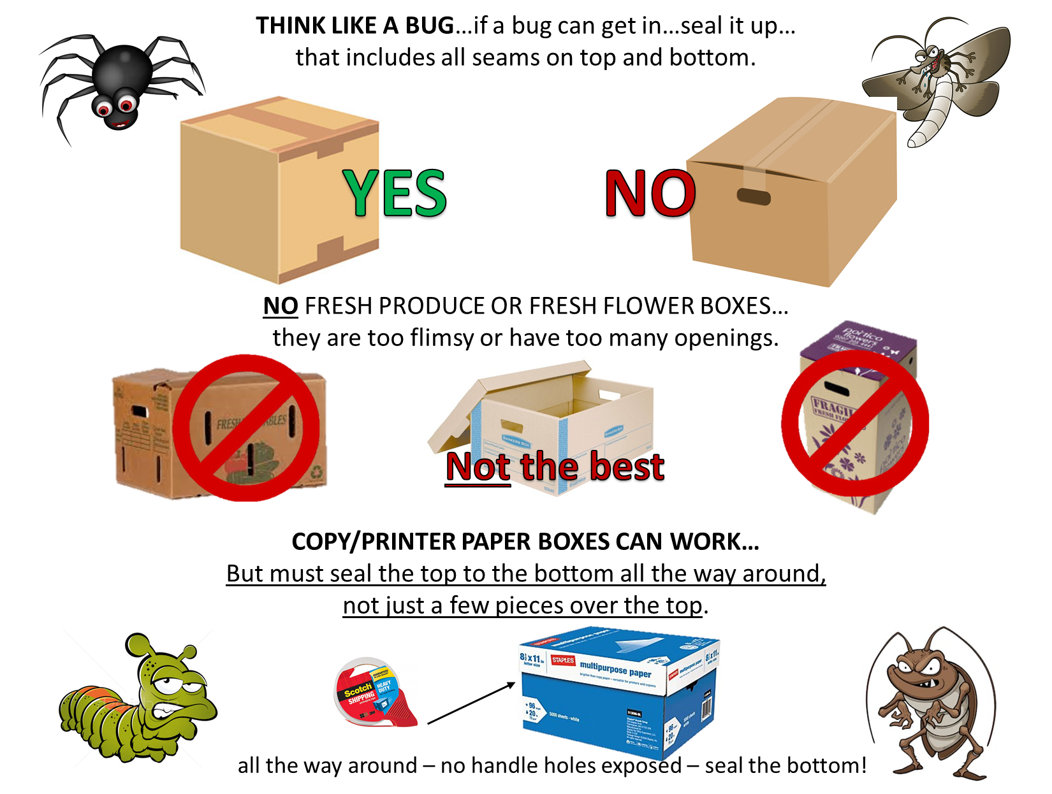
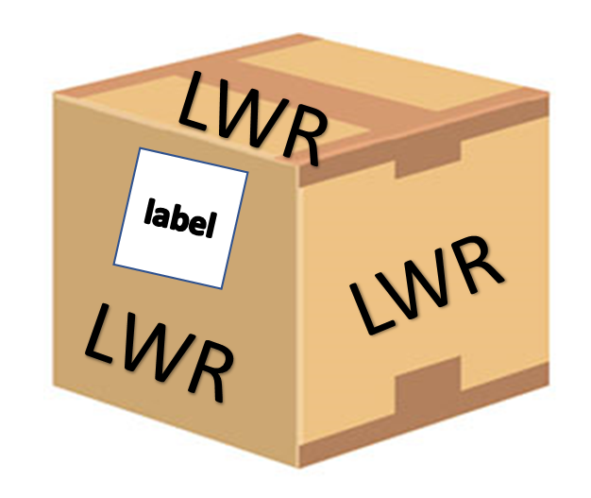
HELPFUL HINTS
- Best way to seal the box is the H-method on TOP and BOTTOM regardless of if the bottom is glued or not.
- No exposed seams or holes.
- Handle-holds seem like a good idea, but they are a NO-NO; seal over them.
- Fill to top of box so they won’t be crushed when stacked.
- No boxes should weigh over 30 pounds.
- The more uniform the shape and size of the boxes the better.
- Tape down the label and put it on one side of the box (not on top). See page 6 for labels.
- Write LWR and number & type of item in large-block-black letters on the top, bottom and all four sides of the box. Example: LWR 10 QUILTS
- Correct packaging and taping is the responsibility of the person bringing the boxes to the ingathering. Make sure they are packed correctly, or your delivery person may have to do triage.
- Do it right, so no one must repack or add more tape.
- Have your ingathering report ready to give to the site coordinator.
- Help us unload your boxes, please.
- Wait until your ingathering has been cleared for shipment before you drive off.
Thanks for supporting
Lutheran World Relief
- Tape down the provided label and put it on one side of the box (not on top).
- Write LWR in large-block-black letters on the top, bottom and all four sides of the box.
- Write on the top, bottom and all four sides of the box its contents (Ex. 10 quilts or 30 school kits, etc.)
- Bring your paperwork to the ingathering site.
- Correct packaging and taping is the responsibility of the person bringing the boxes to the ingathering.
- Do it right, so no one has to repack or add more tape.
- Help us unload your boxes, please.
- Wait until your ingathering has been cleared for shipment.
10 quilts

THRIVENT ACTION TEAMS

Thrivent Action Teams allow you to support the work of Lutheran World Relief while taking part in a meaningful service activity. Thrivent members are eligible to lead a service activity that can be completed within 90 days. Once you are approved to lead a team, Thrivent will send you a Thrivent Action Team Kit and a VISA card up to $250 for your volunteer activity. Go to thrivent.com/actionteam for more information.

Lutheran World Relief
QUILT AND KIT SHIPPING COST
updated 2024

LWR spends over $1.9 million to distribute about $18 million worth of quilts and kits each year. Encourage your contributors to collect monetary contributions to help distribute quilts and kits around the world.
LWR's Approximate Cost to Deliver Quilts and Kits Overseas
One Quilt or Blanket $2.80
One School Kit $2.85
One Personal Care Kit $1.50
One Baby Care Kit $3.10
One Fabric Kit $1.80

Funds can be donated at https://lwr.org/donate/shippingfund or mailed directly to LWR.

LUTHERAN WORLD RELIEF
QUILT & KIT SHIPPING FUND
PO BOX 17061
BALTIMORE, MD 21297-1061

Your generosity ensures LWR has the resources needed to move these items around the world.

DO NOT send Quilt and Kit Shipping donations to the LWML Texas District Financial Secretary or
bring to the ingatherings.


Lutheran World Relief Ingathering Report

Date: __________________________

CONGREGATION NAME: _______________________________________________

Address: _____________________________________________________________

City, State, ZIP Code: ___________________________________________________

Contact Person: _______________________________________________________

Phone: ____________________________Email: _____________________________

CIRCLE ONE: ELCA ELDONA LCMC LCMS NALC

LCMS Churches – LWML Group Name: _____________________________________

LWR ITEM | QUANTITY | # OF BOXES
QUILTS
BLANKETS – No Fleece
SCHOOL KITS
PERSONAL CARE KITS
BABY CARE KITS
FABRIC KITS
QUILT & KIT SHIPPING FUND  (Amount sent directly to LWR) | $

Please complete this form and bring with you to drop-off site. You may also wish to keep a copy for your records.

Church:
________________________________
________________________________
Address:
________________________________
________________________________
________________________________
Contents:
________________________________
Number enclosed: ________________
TO:
LUTHERAN WORLD RELIEF
398 EAST RICHMOND STREET
SOUTH ST. PAUL, MN 55075

Church:
________________________________
________________________________
Address:
________________________________
________________________________
________________________________
Contents:
________________________________
Number enclosed: ________________
TO:
LUTHERAN WORLD RELIEF
398 EAST RICHMOND STREET
SOUTH ST. PAUL, MN 55075

Church:
________________________________
________________________________
Address:
________________________________
________________________________
________________________________
Contents:
________________________________
Number enclosed: ________________
TO:
LUTHERAN WORLD RELIEF
398 EAST RICHMOND STREET
SOUTH ST. PAUL, MN 55075

Church:
________________________________
________________________________
Address:
________________________________
________________________________
________________________________
Contents:
________________________________
Number enclosed: ________________
TO:
LUTHERAN WORLD RELIEF
398 EAST RICHMOND STREET
SOUTH ST. PAUL, MN 55075

