
Congregational Update
Fall 2022
A Terrible, Perfect Storm

Dear Partner in Ministry,

Thank you for your congregation’s partnership with Lutheran World Relief. Your love is making a powerful difference around the world in the lives of our neighbors.

This document includes updates for you to share with your congregation in a variety of ways: newsletter article, bulletin announcement, social media kit and video. It is formatted so that you, your staff or volunteers can copy and paste the text directly into your congregation’s publications.

To share the photos that accompany this update, please use the link on the bottom of page 5 to access and download the images. Please do not copy the photos directly from this document.

Thank you for sharing this story with your congregation about the ways your generosity is reaching our neighbors around the world. We are deeply grateful for your partnership.

Please contact me if I can be of any assistance.



Rev. Lisa Kipp
Director of Congregational Engagement
congregations@lwr.org

We are joining Lutheran World Relief to walk with our neighbors in need.

NEWSLETTER UPDATE
Copy/paste this text into your congregation’s newsletter
Ramata Sawadogo just wants happiness for her children. It’s what any mother wants. But happiness seems like a far-off, impossible dream. Catastrophic hunger threatens her family, making a mother’s simple wish more of an out-of-reach fantasy.
Before the family fled their rural home in Burkina Faso, Ramata grew as much food as her family needed. But violent extremists stormed through her town, leaving her no choice but to leave. And while her family is currently safe, she has little access to food in her new home, grateful if she’s able to feed her children once a day.
Drought, death, fear and hunger plague the people of Burkina Faso. They’ve suffered changing rain patterns, six years of extremist violence and a recent military coup.
A terrible, perfect storm
Ramata is not alone. In places from Burkina Faso to Yemen to Peru, families have found themselves amid increasing desperation and devastation. Crippling drought and famine, divisive and violent political insecurity — and the COVID-19 pandemic — have converged to result in increasing food prices around the globe. The war in Ukraine has only compounded the crisis, pushing vulnerable communities further into dangerous cycles of hunger and suffering. It is a terrible, perfect storm.
Our congregation can help
In the midst of this overwhelming storm, we can feel at a loss for a solution. But we can be the answer to the prayers of our neighbors in crisis, including mothers like Ramata, by supporting Lutheran World Relief. Our congregation can walk alongside our neighbors amid this storm and bring God’s love to those who are suffering. To learn more, visit lwr.org or [insert specific congregational information here].

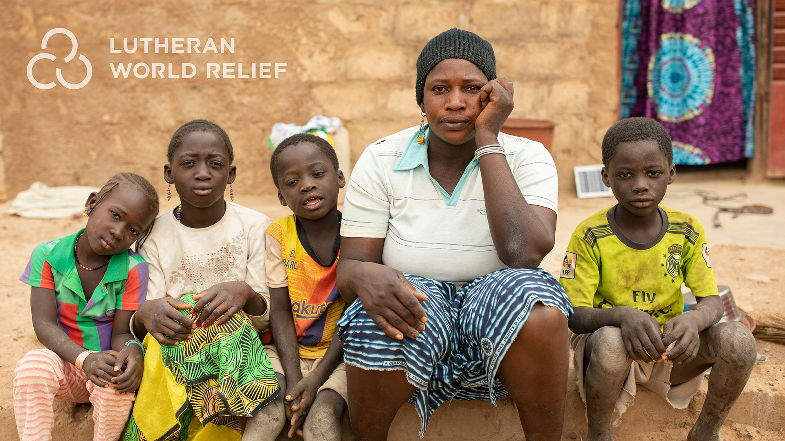
Ramata Sawadogo and children fled violence in their hometown in Burkina Faso only to face devastating hunger. Extreme weather is making drought a more common occurrence in this part of the world, where farmers are dependent on the land for their livelihood and sustenance. Ramata’s family is not alone. In places from Burkina Faso to Yemen to Peru, families have found themselves amid increasing desperation and devastation.



We are joining Lutheran World Relief to walk with our neighbors in need.

BULLETIN UPDATE
Copy/paste this text into your congregation’s bulletin
In places from Burkina Faso to Yemen to Peru, families have found themselves amid increasing desperation and devastation. Crippling drought and famine, violence and the lingering impacts of the COVID-19 pandemic — have all converged to result in increasing food prices around the globe. The war in Ukraine has only compounded the crisis, pushing vulnerable communities further into dangerous cycles of hunger and suffering. It is a terrible, perfect storm. Will you join us in walking alongside our neighbors amid this storm and bringing God’s love to those who are suffering? To learn more, visit lwr.org or [insert specific congregational information here].

Share this social media update on your congregation’s Facebook page. The photos included can all be downloaded at the link below. Please do not copy the photos directly from this document.
SOCIAL MEDIA UPDATE
Copy/paste this text into your congregation’s Facebook page

To share this update:
- Download the images below using this link. Please do not copy and save the photos directly from this document.
- Create a new post on your congregation’s Facebook page.
- Copy and paste the bold text below into the status message.
- Add the photos you downloaded to your post.
- Hover over the photos with your mouse and click on Edit All. Copy and paste the photo descriptions (below, to right of photos) in each photo caption box.
- Click on Done.
- Click on Post.

We are joining Lutheran World Relief to walk with our neighbors in need.

“I just want happiness for my children.” It’s what any mother wants. But happiness seems like a far-off, impossible dream for Ramata Sawadogo and her children. In places from Burkina Faso to Yemen to Peru, families have found themselves amid increasing desperation and devastation.

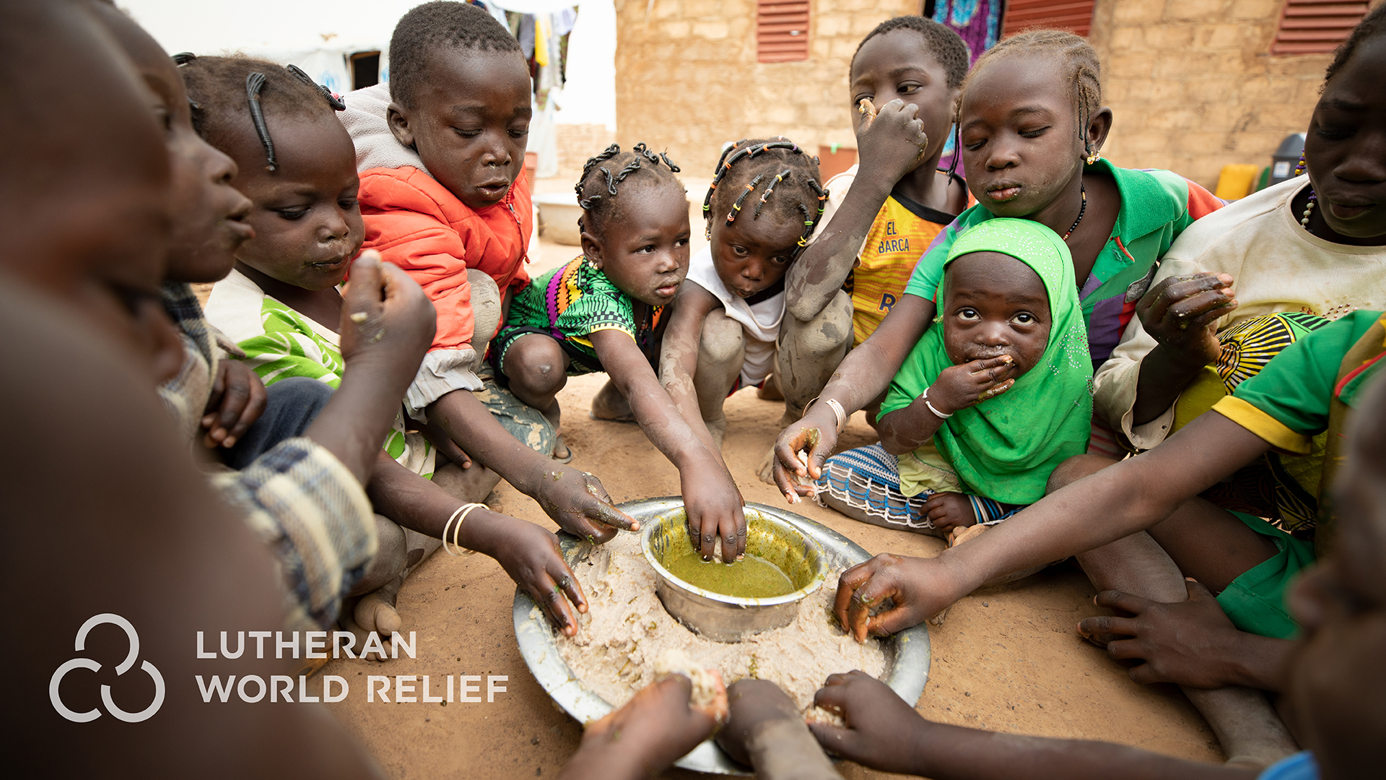
Crippling drought and famine, divisive and violent political insecurity — and the COVID-19 pandemic — have converged to result in increasing food prices around the globe. The war in Ukraine has only compounded the crisis, pushing vulnerable communities further into dangerous cycles of hunger and suffering. It is a terrible, perfect storm.

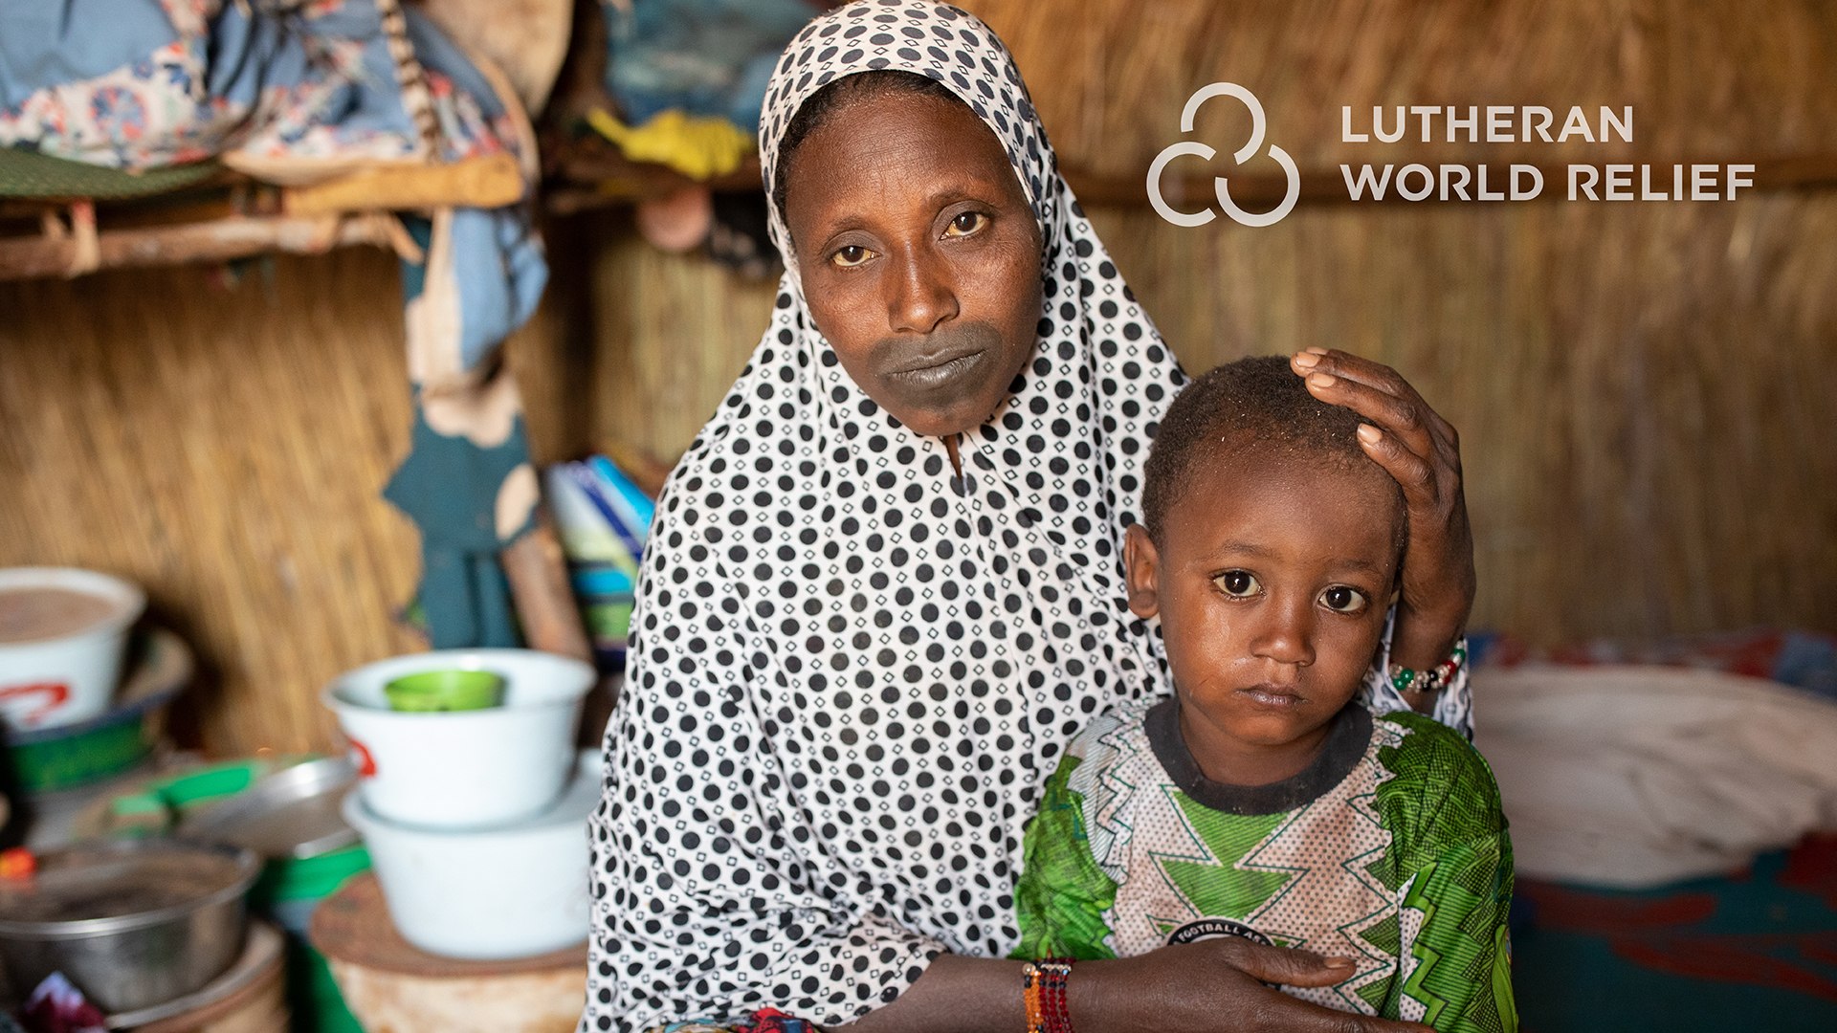
In Mali, Fatima Bolly fled with her eight children when violence reached her village, but now with no means of income or regular food source, she faces the cruel reality of hunger and malnutrition. A lack of resources and poverty often drive further violence and conflict, pushing already suffering communities to the brink of devastation.

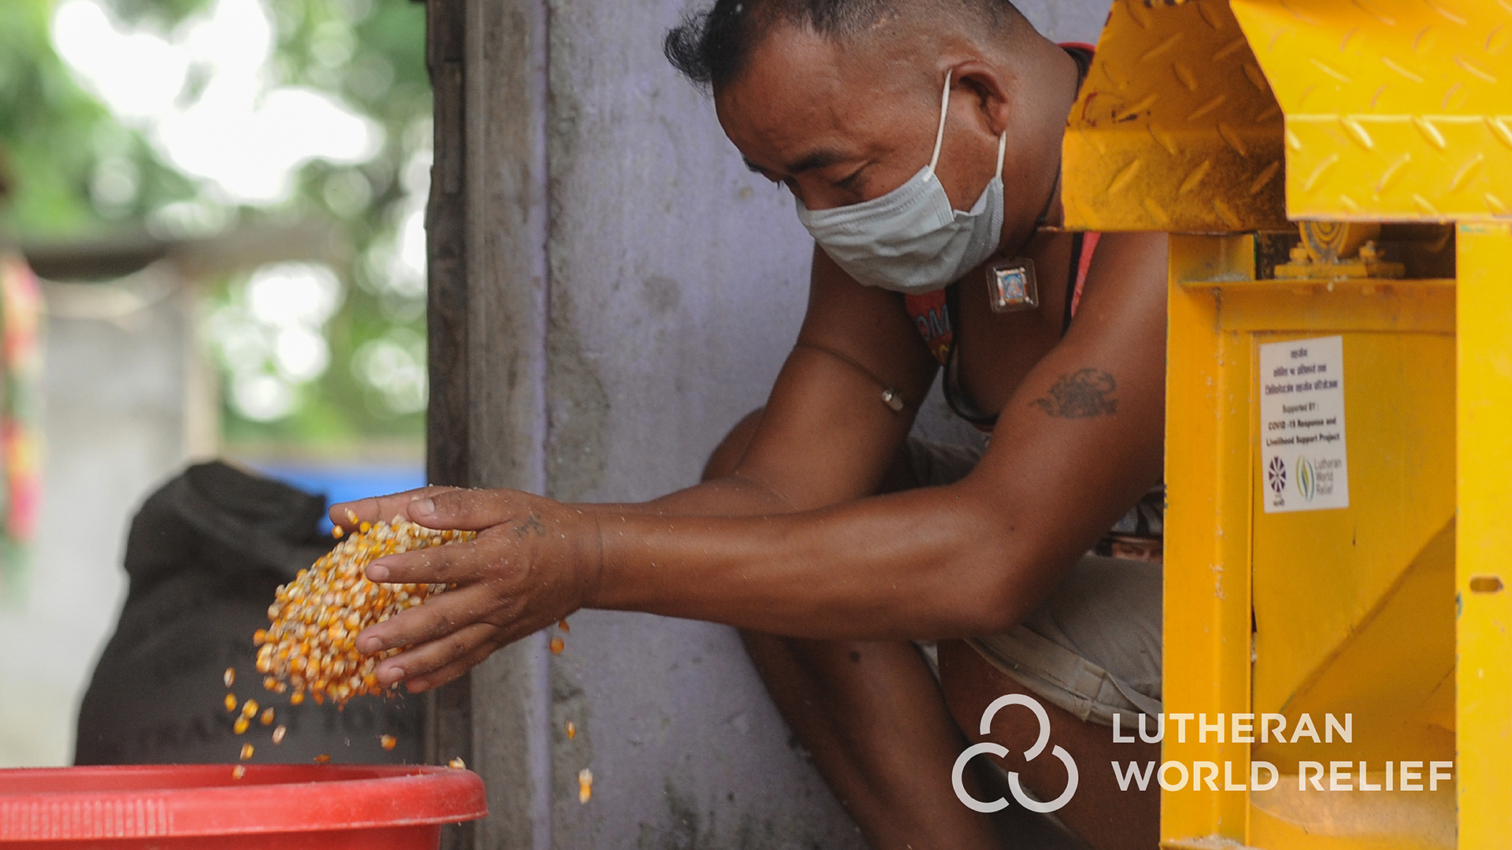
In Nepal, the COVID pandemic impacted laborers like Dhan Bahadur Gurung. A lack of available workers made it difficult to continue with maize production. He received this machine that helped with the process and allowed him to still earn an income but the lingering impacts of COVID are still being felt worldwide.

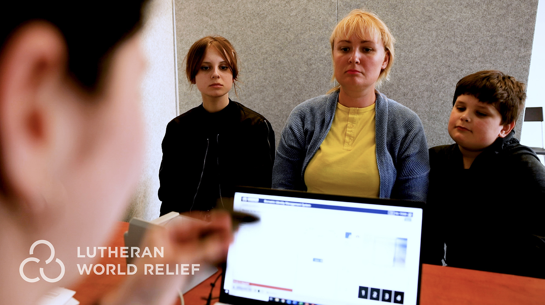
In Poland, Ilnytska Alina Yevhenivna and her children register to receive emergency cash funds after fleeing the war in Ukraine. The conflict has compounded already vulnerable situations by pushing up food prices and crippling supply chains.

In the midst of this overwhelming storm, we can feel at a loss for a solution. But we can be the answer to the prayers of our neighbors in crisis by sharing our love through Lutheran World Relief. Our congregation can walk alongside our neighbors amid this storm and bring God’s love to those who are suffering. To learn more, visit lwr.org or [insert specific congregational information here].

TO DOWNLOAD AND SHARE THESE PHOTOS, VISIT:
https://photos.lwr.org/?c=3683&k=7d3d74c4ac

VIDEO TO SHARE
Share this video in worship or on your congregation’s Facebook page



View and share video on YouTube: https://youtu.be/KOEdSHK2Ao8

Download and share video: https://photos.lwr.org/?r=40775&k=c893633fee

